MONITORING

Texas has approximately 1,200 Local Education Agencies (LEAs), more than any other state in the country. These include all local school systems in Texas, both traditional Independent School Districts (ISDs), Consolidated Independent School Districts (CISDs), and charter schools. To provide the level of support and oversight required for this many LEAs and the students they serve, TEA must significantly increase its monitoring capacity and ensure that monitoring focuses on improvements for students, in addition to fulfilling minimum expectations for compliance with federal requirements. This requires the adoption of a more holistic approach to monitoring that takes into account compliance-based indicators while also looking for best practices. Texas must seize the opportunity to share this information across the state, allowing for greater peer collaboration and innovative solutions for improvement.

Texas LEAs have diverse and unique needs. Therefore, differences in LEA type and size require differentiated technical assistance. Further, some LEAs may require more intensive support and monitoring, while some LEAs may simply require routine desk reviews. This strategic plan highlights the state’s approach to the need for differentiation. It also meets the needs outlined in the USED’s corrective action requirements (see appendix C).

Review and Support Team (CA: 4.a.)

The Review and Support team will be a new unit housed in the TEA Office of Academics (see Figure 5 below). This team will have three primary responsibilities:
- to monitor LEAs related to IDEA and federal and state statutes using a risk assessment index and holistic student-centered practices;
- to provide targeted technical assistance and support for LEAs related to special education; and
- to escalate support for LEAs experiencing significant challenges as well as to highlight those LEAs that demonstrate clear success.
The Review and Support team should not adopt a narrow focus on process and legal requirements, but rather be guided by an effort to support the most effective practices that lead to improved outcomes for students.

The Review and Support team will be functionally separated into two units. The first unit will consist of special education staff who will complete on-site and desk monitoring activities. This team will be staffed to allow for annual desk reviews of one-third (1/3) of LEAs in the state. The monitoring system will include both quantitative and qualitative indicators, and will consider data points that may include disability indicator(s), specific strategies or interventions listed in a student's individualized education program (IEP), student achievement, LEA staffing, local policies and procedures, and compliance indicators in alignment with federal and state law (e.g., meeting timelines for evaluations, parent and family participation and inclusion, etc.). Quantitative indicators will likely include both compliance indicators (e.g., timeliness and completeness of individual initial evaluations) and performance indicators (e.g., participation and achievement levels of students with disabilities in the general curriculum). Qualitative indicators will likely include, to the extent permitted by law, anonymous survey and interview results collected from educators and parents. Surveys and interviews will likely consider local policies as well as local practices.

LEAs will be required to submit information through Public Education Information Management System (PEIMS, described later in this section) for review. LEAs may be asked to submit additional information related to randomly selected students to allow for a holistic review of information without the disruption of on-site visits (including Admission Review and Dismissal (ARD) committee information, IEP reviews, teacher interviews, and the opportunity for families to provide feedback). Any student interviews would require parental consent. This monitoring and data collection process utilizes a secure data collection site that allows only authorized state agency (and applicable district) personnel to review any student records and/or conduct interviews (in alignment with state and federal law). This secure process will ensure that student data remains confidential.

In addition to LEA desk reviews, select LEAs will also receive on-site visits. The review and support team size will be structured such that up to 20 percent of the LEAs in Texas could receive an on-site visit in any given year. On-site visiting could be a result of random selection, a result of the desk review, ongoing or frequent complaints to TEA, or in partnership with other state agency monitoring. The structure of the
on-site visit would depend on the reason for the visit. Unannounced visits will focus on observing processes in action, speaking with stakeholders when possible, and conducting additional reviews of actual practices. These visits will provide opportunities for giving feedback and connecting LEAs to technical assistance. They will also allow the reviewers to identify bright spots and best practices to share broadly. The visits will be structured to minimize disruption to LEA and school activities. As the content to be reviewed may be unannounced, there would be no need for visit preparation on the LEA's part, assuming that all files and documents are appropriately organized (as they should be). For those LEAs that receive on-site visits due to identified risk factors, the visit may include requests to view student files, observation of records of supports provided, and more conversations with multiple layers of the organization. The review activities will be determined on an individual basis.

The review and support team will also include an escalation unit comprised of special education specialists. This small and flexible unit will be used for LEAs that are significantly out of compliance, and/or for those LEAs that require or request intensive support. The purpose of the escalation unit – as with the larger review and support team is focused less on documenting a running list of problems and more about supporting the identification and implementation of solutions. The escalation unit may remain on-site for longer periods of time and provide more intensive support.

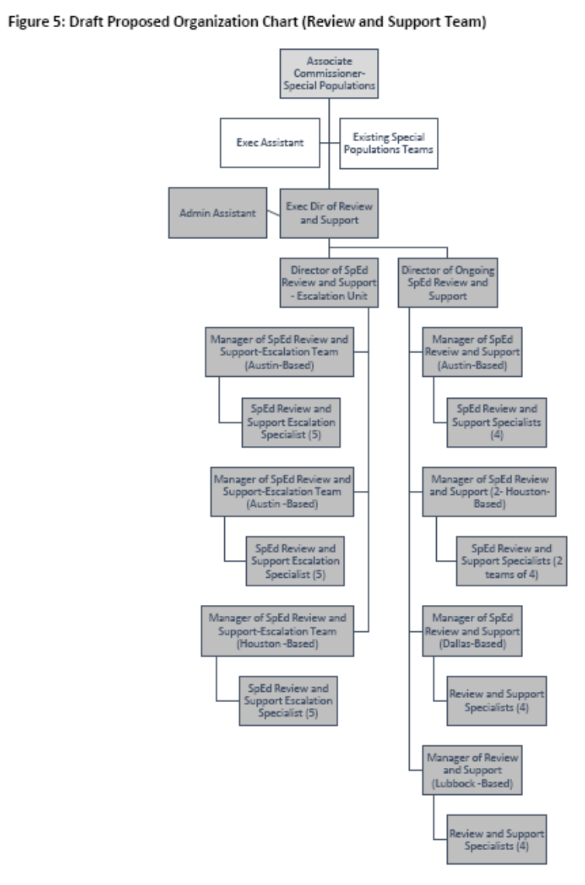
Non-Compliance
34 CFR §300.600 requires TEA, as the state education agency, to monitor all local education agencies(LEAs) in the state to ensure compliance with IDEA requirements. In accordance with 34 CFR§300.600(a)(3), if TEA determines that an LEA is not in compliance, TEA must use appropriate enforcement mechanisms, including, as necessary, technical assistance, conditions on funding, implementation of a corrective action plan, or the withholding of funds in whole or in part.

In furtherance of this IDEA requirement, TEC §29.010 authorizes TEA to “develop and implement a system of sanctions for school districts whose most recent monitoring visit shows a failure to comply with major requirements of [IDEA], federal regulations, state statutes, or agency requirements necessary to carry out federal law or regulations or state law relating to special education.” These interventions and sanctions are found at 19 TAC §89.1076, and include, but are not limited to:

- on-site review for failure to meet program or compliance requirements;
- required fiscal audit of specific programs and/or of the district, paid for by the district;
- required submission of corrective actions, including compensatory services, paid for by the district;
- required technical assistance, paid for by the district;
- public release of program or compliance review findings;
- special investigation and/or follow-up verification visits;
- required public hearing conducted by the local school board of trustees;
- assignment of a special purpose monitor, conservator, or management team, paid for by the district;
- hearing before the commissioner of education or designee;
- reduction in payment or withholding of funds;
- lowering of the special education monitoring/compliance status and/or the accreditation rating of the district; and/or;
- other authorized interventions and sanctions as determined by the commissioner.

IDEA requires TEA, in exercising its monitoring duties, to ensure that identified noncompliance is corrected “as soon as possible, and in no case later than one year after the State’s identification of the noncompliance.” 30 CFR §300.600(e). State law mandates that if a district remains in noncompliance for more than one year, “the first stage of sanctions shall begin with annual or more frequent monitoring visits. Subsequent sanctions may range in severity up to the withholding of funds,” which the agency may use to provide services to the students and staff within the noncompliant LEA. TEC §29.010(d).

Review Process Development

TEA will develop a standardized process for conducting reviews, including development of documentation and reporting templates to be used. The standardized review process will be developed with stakeholder consultation to ensure maximal effectiveness for students. TEA may work with external organizations to ensure stakeholder feedback is properly integrated into the review process design. Part of the process design will include an internal reviewing mechanism to ensure processes are completed with fidelity to the purpose of helping students and to avoid the bureaucratic tendency to focus solely
on compliance.

Monitoring visits will follow a standardized process. They will also result in a published report. These reports will be available in a searchable database on the TEA Special Education website. LEAs will have the opportunity to respond to any report, along with an opportunity to discuss relevant topics in post- meetings. LEAs would also have an opportunity to provide additional information on planned corrective action steps using a standardized format to be included as part of the report. Nonetheless, the agency will remain focused on data privacy. As such, in accordance with law, all student information, or information that would reasonably identify protected persons, will be removed from the report. Furthermore, data aspects that would normally be public will be limited, as required by law, for very small LEAs, given the issues with small data samples.

LEAs may have the opportunity to request "support visits" from the state in advance of on-site reviews. These may be helpful for LEAs to identify areas for growth, or to solicit feedback around existing structures. Support visits are optional and would be done by request.

Again, on-site monitoring visits can create some disruption to campuses and LEAs. However, TEA is committed to sharing clear expectations and supporting best practices so that LEA visits can be structured to reduce disruption at the host site. Visits will not be conducted during state testing.

TEA will develop an independent review of the standardized monitoring process, as a check on its own process implementation quality.

Data Collection

To accommodate desk reviews, TEA will need to collect additional data from LEAs. TEA will ensure that its data collections provide adequate information for monitoring, while maintaining strong controls on data privacy. This could include the following, as allowable in state or federal statute:

- Parent- and staff-generated requests for special education initial evaluation;
- Complete information on all categories under which a child qualified for special education;
- Information on the interventions that are in place for the child;
- Additional information on Section 504 and Rtl;
- Sample schedules;
- Services offered and provided, including frequency;
- Number of students who were referred for evaluation, the number evaluated, and the number who qualified after evaluation; and
- Coding of dyslexia, dyscalculia and dysgraphia.

Additional indicators may be identified on a rolling basis once the new monitoring process is implemented. All new data collections are subject to all statutorily required reviews, including a review through the agency's Data Governance Board.

Other Related Work
TEA will review and potentially propose administrative rule revisions to ensure clear compliance with the law and alignment with best practices for serving students with disabilities. For example, TEA may propose rule revisions to 19 Texas Administrative Code (TAC) 89.1050 to require LEAs to provide the Dispute Resolution Handbook and explain rights to parents when there is disagreement in the ARD committee. TEA will also look into opportunities for reducing administrative burden on duplicative or unnecessary paperwork, to allow for more aligned systems and structures to be put into place.

