DEFINING THE NEED FOR CHANGE

Special education participation and performance trends in Texas highlight the need to improve. One area of focus is student access to special education support. The following graph notes the decline in special education participation in Texas until the most recent years:

Figure 1: Special Education Enrollment Rates

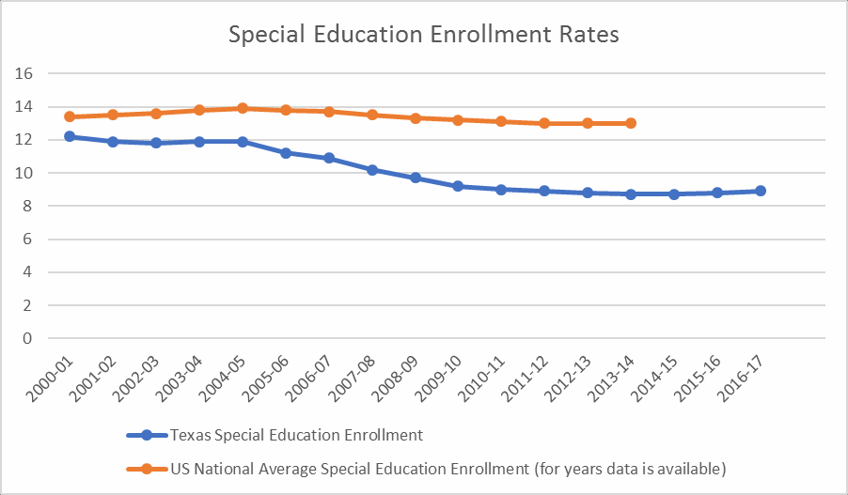

Changes in special education participation can be the result of a variety of factors, as each student should be considered individually. But during a monitoring visit in late 2016, the USED found that “some school districts took actions specifically designed to decrease the percentage of children identified as children with disabilities under the IDEA to 8.5 percent or below,” and cited TEA for not “[ensuring] that all [school systems] in the State properly identified, located, and evaluated all children with disabilities residing in the State who were in need of special education and related services, as required by 34 CFR §300.111.” As a result, the USED required TEA to correct the noncompliance.

USED found that not all eligible students have been given timely access to special education services. While USED did not examine the efficacy of special education services, an analysis of student outcomes in the areas of graduation rates, achievement in reading and mathematics, and college readiness measures indicate we have room for significant improvements.

Figure 2: Four-Year Graduation Rates Figure 3: 2017 STAAR Results
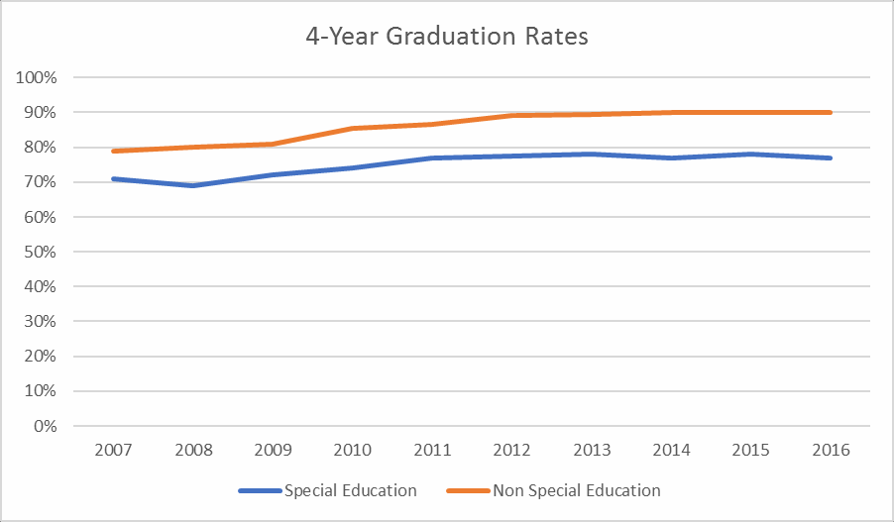
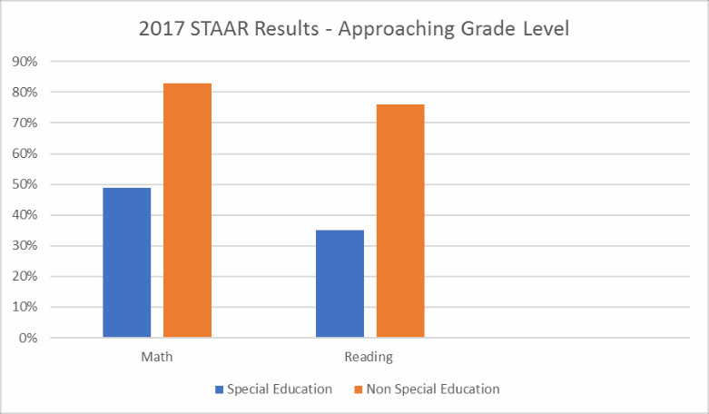
Figure 4: College Readiness (Class of 2016)2

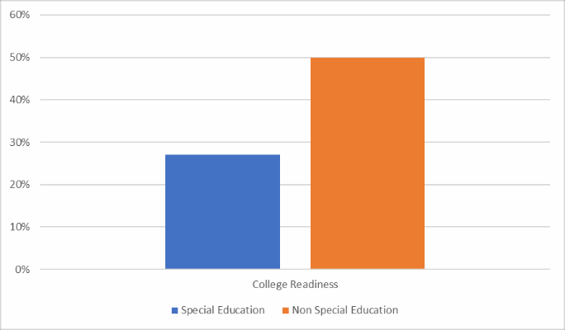

These data highlight significant gaps in performance between students served by special education and their non-disabled peers. For the majority of students served by special education, performing on level academically with their non-disabled peers is an attainable and reasonable goal. We should work to eliminate the gaps in performance exposed by these data.

But these data alone cannot describe the full picture of special education efficacy in Texas. Therefore, the agency set out to solicit feedback directly from special education stakeholders throughout the state. As further described in Appendix A, feedback was received from students, parents, teachers, school administrators, advocates, and others, in every region of the state and in school systems that ranged from large urban to suburban to rural, and including charters.

This anecdotal feedback, combined with the data, informed the decision to develop a comprehensive strategic plan for special education in Texas.

This strategic plan includes steps that address the corrective actions related to Child Find required by USED. Appendix C in this document is the Corrective Action Response (CAR). Those are referenced throughout this document by their Corrective Action Number from the appendix (ex: CA:1.a). However, this strategic plan is broader and goes far beyond what the USED requires through the CAR. The broader steps of this strategic plan are meant to help more fully support students eligible for special education in every aspect of their education, focused not just on access to supports but also on improved outcomes from those supports.

Given the needs identified, this strategic plan is organized around a few primary focus areas:

• Monitoring
• Identification, Evaluation, and the offer of free appropriate public education (FAPE)
• Training, Support, and Development
• Student, Family, and Community Engagement
• Technical Assistance Networks

The Agency expects this strategic plan to change as situations warrant. As the process evolves, the agency is committed to two key beliefs to help ensure a process of continuous improvement:

• Significant Stakeholder Input: TEA is committed to including significant stakeholder engagement. This includes engaging with students with disabilities, families, educators, advocacy groups, and district and school officials, among others. This also means that there must be multiple, varied opportunities for stakeholders to provide this feedback. Texas cannot improve special education services in a way that students with disabilities deserve without concentrated collaboration among stakeholders in the special education community. It should be noted that the development of this strategic plan is not the end of the feedback process. Regular feedback will be solicited throughout the strategic plan’s execution.
• Transparency: TEA’s rulemaking and stakeholder processes are and will continue to be made public to the extent allowed by law.

Please note that this is a strategic plan. The details around many of these initiatives will unfold as the work progresses. The agency also plans to continue its engagement with stakeholders as outlined below. TEA will produce materials intended for parents/guardians in both English and Spanish and strongly encourages all school systems to do the same.

With these beliefs firmly embedded in TEA’s processes for planning and execution of this strategic plan, we should have an effective framework for collaborative continuous improvement that delivers real results for our students.

